模块式安装php-5.4.40及xcache

环境介绍：

操作系统：CentOS release 6.7 (Final)

所需软件：php-5.4.40.tar.bz2,xcache-3.2.0.tar.bz2

开发环境：Development Tools, Server Platform Development

httpd版本：httpd-2.4.25

数据库版本：mariadb-5.5.43

目标：php编译为httpd的模块

0、解决依赖关系

(1）配置好yum源（系统安装源及epel源）

使用阿里云镜像站点作为epel源，安装如下：

# wget <https://mirrors.aliyun.com/epel/epel-release-latest-6.noarch.rpm>

# rpm -ivh epel-release-latest-6.noarch.rpm

（2）安装相关依赖包

# yum -y install bzip2-devel libmcrypt-devel libxml2-devel

1、下载源码安装包

php官网下载：<http://php.net/downloads.php>

xcache官网下载：wget <http://xcache.lighttpd.net/pub/Releases/3.2.0/xcache-3.2.0.tar.bz2>

2、编译安装php-5.4.40

src]# tar -xf php-5.4.40.tar.bz2

src]# cd php-5.4.40

php-5.4.40]# ./configure --prefix=/usr/local/php --with-mysql=/usr/local/mysql/ --with-mysqli=/usr/local/mysql/bin/mysql_config --with-apxs2=/usr/local/apache/bin/apxs --enable-mbstring --with-freetype-dir --with-jpeg-dir --with-png-dir --with-zlib --with-libxml-dir --enable-xml --enable-sockets --with-mcrypt --with-bz2 --with-config-file-path=/etc/php/php.ini --with-config-file-scan-dir=/etc/php.d/

php-5.4.40]# make

php-5.4.40]# make test

php-5.4.40]# make install

--prefix：默认安装目录

--with-mysql：指明mysql安装路径,标准路径：/usr/local/mysql

--with-openssl：指明使用openssl功能

--with-mysqli：mysql的另外一种访问接口，在某些嵌入式访问中可能用到，不重要，此次可以不使用

--enable-mbstring：指明php支持多字节文本

--with-freetype-dir：指明freetype字库目录，可能需要事先安装freetype-devel包。

--with-jpeg-dir：指明支持jpeg格式图片生成

--with-png-dir：指明支持png格式图片

--with-zlib：指明支持zlib

该模块使您可以通过使用gzip压缩文件（以及未压缩文件，但不包含套接字）的大多数文件系统功能的版本，透明地读取和写入gzip（.gz）压缩文件。

--with-libxml：指明xml lib库，依赖libxml2-devel包，需事先安装

--enable-xml：启用支持xml文档的处理

--enable-sockets：启用sockets功能

--with-apxs2：指明apache apxs的路径；此参数指明要把php编译为httpd的模块。

apxs是一个为Apache HTTP服务器编译和安装扩展模块的工具，用于编译一个或多个源程序或目标代码文件为动态共享对象，使之可以用由mod_so提供的LoadModule指令在运行时加载到Apache服务器中。

--with-mcrypt：依赖libmcrypt-devel包，需事先安装，在epel源中才有。

mcrypt 是php里面重要的加密支持扩展库，linux环境下该库在默认情况下不开启

--with-config-file-path：指明主配置文件路径

--with-config-file-sca：指明扫描置顶路径下所有以.ini结尾配置文件

--with-bz2：指明支持bz2，依赖bzip2-devel包，需事先安装

bzip2 函数用于透明地读写 bzip2（.bz2）压缩文件。

--enable-maintainer-zts：启用php支持多线程模式，此参数表明开启线程安全。

说明：

（1）、这里为了支持apache的worker或event这两个MPM，编译时使用了—enable-maintainer-zts选项。

（2）、如果使用PHP5.3以上版本，为了链接MySQL数据库，可以指定mysqlnd，这样在本机就不需要先安装MySQL或MySQL开发包了。mysqlnd从php 5.3开始可用，可以编译时绑定到它（而不用和具体的MySQL客户端库绑定形成依赖），但从PHP 5.4开始它就是默认设置了。

# ./configure --with-mysql=mysqlnd --with-pdo-mysql=mysqlnd --with-mysqli=mysqlnd

注意：刚开始使用的数据库是mariadb-5.5.40，但在编译php-5.4.40时一直报下面的这个错误：

/usr/local/mysql//include/mysql/my_config.h:654:2: 错误：#error <my_config.h> MUST be included first!

make: *** [ext/mysqli/mysqli.lo] 错误 1

前面使用二进制格式安装的mariadb-5.5.40头文件都已经连接至/usr/include/mysql目录下了，my_config.h确定是存在的，搞不清怎么回事儿；这其实是一个mariadb-5.5.40的bug，换成mariadb-5.5.43就编译通过了，但观察发现编译时还有有报warning，具体原因不明。其实马哥在讲课时已经说了这个问题，因为我看的是视频当时也不知道是这么个bug，终于这个坑还是要亲自踩一次的。

3、为php提供配置文件

php-5.4.40]# mkdir /etc/php

php-5.4.40]# cp php.ini-production /etc/php/php.ini

此时http 的php_module已经加载了，查看httpd.conf配置文件,LoadModule php5_module modules/libphp5.so指令已经开启，使用httpd -M 命令查看，php5_module (shared)确实已经加载，但此时http还不支持php网页，可以新建一个index.php网页测试

# vim /usr/local/apache/htdocs/index.php

<?php

phpinfo();

?>

所以还需要配置httpd支持php网页。

4、编辑apache配置文件httpd.conf，以apache支持php

]# vim /etc/httpd/httpd.conf

（1）添加如下两行

AddType application/x-httpd-php .php

AddType application/x-httpd-php-source .phps

（2）定位至DirectoryIndex index.html

修改为：

DirectoryIndex index.php index.html

修改完成后重新启动httpd，即可测试php是否已经可以正常使用。

测试页面index.php示例如下：

<?php

$link = mysql_connect('127.0.0.1','root','');

if ($link)

echo "Success...";

else

echo "Failure...";

mysql_close();

?>

6、部署phpMyAdmin进行测试

（1）下载phpMyAdmin

src]# wget https://files.phpmyadmin.net/phpMyAdmin/4.0.10.20/phpMyAdmin-4.0.10.20-all-languages.zip

（2）解压

src]# unzip phpMyAdmin-4.0.10.20-all-languages.zip

（3）将解压后的phpMyAdmin移动到/usr/local/apache/htdocs/目录下，并重命名为pma

src]# mv phpMyAdmin-4.0.10.20-all-languages /usr/local/apache/htdocs/pma

（4）准备配置文件

src]# cd /usr/local/apache/htdocs/pma

pma]# cp config.sample.inc.php config.inc.php

（5）访问测试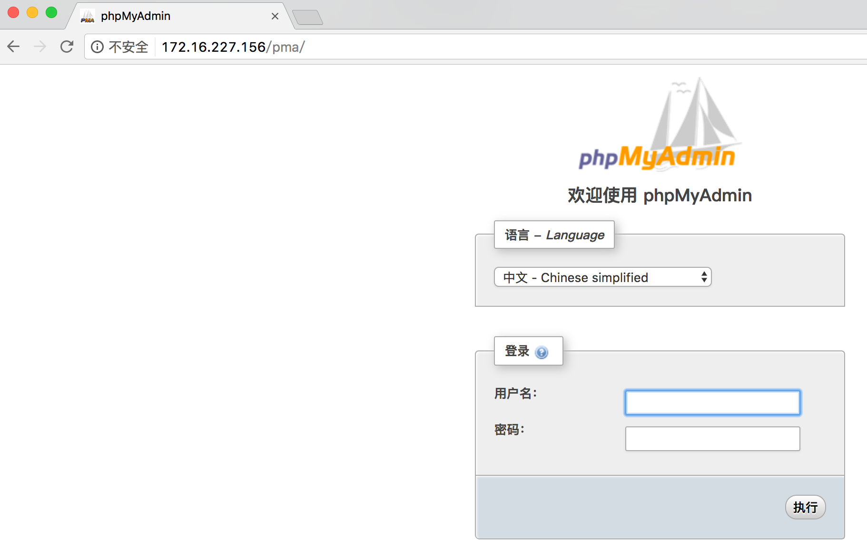

7、使用ab工具测网页性能

(1)访问动态

~]# ab -n 1000 -c 50 http://172.16.227.156/pma/index.php

This is ApacheBench, Version 2.3 <$Revision: 1757674 $>

Copyright 1996 Adam Twiss, Zeus Technology Ltd, http://www.zeustech.net/

Licensed to The Apache Software Foundation, http://www.apache.org/

Benchmarking 172.16.227.156 (be patient)

Completed 100 requests

Completed 200 requests

Completed 300 requests

Completed 400 requests

Completed 500 requests

Completed 600 requests

Completed 700 requests

Completed 800 requests

Completed 900 requests

Completed 1000 requests

Finished 1000 requests

Server Software: Apache/2.4.25

Server Hostname: 172.16.227.156

Server Port: 80

Document Path: /pma/index.php

Document Length: 8714 bytes <—页面大小

Concurrency Level: 50

Time taken for tests: 28.693 seconds

Complete requests: 1000

Failed requests: 0

Total transferred: 10242582 bytes

HTML transferred: 8714000 bytes

Requests per second: 34.85 [#/sec] (mean) <—每秒处理请求34.85个？虚拟机性能不行。

Time per request: 1434.628 [ms] (mean)

Time per request: 28.693 [ms] (mean, across all concurrent requests)

Transfer rate: 348.61 [Kbytes/sec] received

Connection Times (ms)

min mean[+/-sd] median max

Connect: 0 5 23.7 0 193

Processing: 580 1420 154.1 1417 1925

Waiting: 578 1325 133.6 1317 1745

Total: 580 1424 150.6 1420 1925

Percentage of the requests served within a certain time (ms)

50% 1420

66% 1467

75% 1502

80% 1530

90% 1611

95% 1669

98% 1737

99% 1779

100% 1925 (longest request)

（2）访问静态

~]# ab -n 1000 -c 50 http://172.16.227.156/test.html

This is ApacheBench, Version 2.3 <$Revision: 1757674 $>

Copyright 1996 Adam Twiss, Zeus Technology Ltd, http://www.zeustech.net/

Licensed to The Apache Software Foundation, http://www.apache.org/

Benchmarking 172.16.227.156 (be patient)

Completed 100 requests

Completed 200 requests

Completed 300 requests

Completed 400 requests

Completed 500 requests

Completed 600 requests

Completed 700 requests

Completed 800 requests

Completed 900 requests

Completed 1000 requests

Finished 1000 requests

Server Software: Apache/2.4.25

Server Hostname: 172.16.227.156

Server Port: 80

Document Path: /test.html

Document Length: 13634 bytes

Concurrency Level: 50

Time taken for tests: 0.140 seconds

Complete requests: 1000

Failed requests: 0

Total transferred: 13894000 bytes

HTML transferred: 13634000 bytes

Requests per second: 7160.09 [#/sec] (mean) <—访问静态还可以

Time per request: 6.983 [ms] (mean)

Time per request: 0.140 [ms] (mean, across all concurrent requests)

Transfer rate: 97150.71 [Kbytes/sec] received

Connection Times (ms)

min mean[+/-sd] median max

Connect: 0 1 0.6 1 5

Processing: 2 6 1.7 5 13

Waiting: 0 5 1.7 5 13

Total: 3 7 1.7 6 13

Percentage of the requests served within a certain time (ms)

50% 6

66% 7

75% 7

80% 8

90% 9

95% 10

98% 12

99% 13

100% 13 (longest request)

结论：影响网站的速度一般都是动态内容。

8、安装xcache-3.2.0进行php加速

src]# tar xf xcache-3.2.0.tar.bz2

src]# cd xcache-3.2.0

xcache是PHP的模块所以它没有configure命令，需使用phpize命令来生成configure命令。

xcache-3.2.0]# /usr/local/php/bin/phpize

Configuring for:

PHP Api Version: 20100412

Zend Module Api No: 20100525

Zend Extension Api No: 220100525

xcache-3.2.0]# ./configure --enable-xcache --with-php-config=/usr/local/php/bin/php-config

--enable-xcache：启用xcache

--with-php-config：指明php配置接口

xcache-3.2.0]# make

xcache-3.2.0]# make install

Installing shared extensions: /usr/local/php/lib/php/extensions/no-debug-non-zts-20100525/

9、配置php支持xcache

xcache-3.2.0]# mkdir /etc/php.d

xcache-3.2.0]# cp xcache.ini /etc/php.d/

xcache-3.2.0]# cd /etc/php.d/

php.d]# vim xcache.ini

找到extension开头的行，修改为如下行：

extension = /usr/local/php/lib/php/extensions/no-debug-non-zts-20100525/xcache.so

10、重启httpd服务进行测试

]# service httpd restart

Stopping httpd: [ OK ]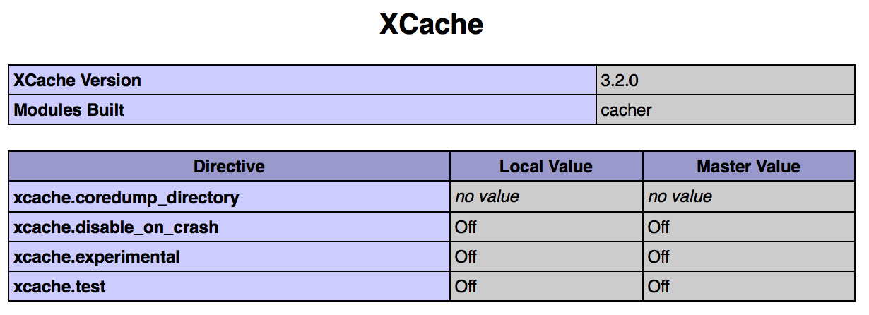

11、使用ab再次测试

（1）动态

[root@web1 ~]# ab -n 1000 -c 50 http://172.16.227.156/pma/index.php

This is ApacheBench, Version 2.3 <$Revision: 1757674 $>

Copyright 1996 Adam Twiss, Zeus Technology Ltd, http://www.zeustech.net/

Licensed to The Apache Software Foundation, http://www.apache.org/

Benchmarking 172.16.227.156 (be patient)

Completed 100 requests

Completed 200 requests

Completed 300 requests

Completed 400 requests

Completed 500 requests

Completed 600 requests

Completed 700 requests

Completed 800 requests

Completed 900 requests

Completed 1000 requests

Finished 1000 requests

Server Software: Apache/2.4.25

Server Hostname: 172.16.227.156

Server Port: 80

Document Path: /pma/index.php

Document Length: 8714 bytes

Concurrency Level: 50

Time taken for tests: 5.654 seconds

Complete requests: 1000

Failed requests: 0

Total transferred: 10242564 bytes

HTML transferred: 8714000 bytes

Requests per second: 176.87 [#/sec] (mean) <—提升不止一点

Time per request: 282.692 [ms] (mean)

Time per request: 5.654 [ms] (mean, across all concurrent requests)

Transfer rate: 1769.15 [Kbytes/sec] received

Connection Times (ms)

min mean[+/-sd] median max

Connect: 0 4 19.7 0 123

Processing: 71 276 80.8 271 919

Waiting: 33 228 76.6 221 798

Total: 98 280 77.5 273 919

Percentage of the requests served within a certain time (ms)

50% 273

66% 299

75% 312

80% 322

90% 357

95% 393

98% 515

99% 619

100% 919 (longest request)

（2）静态

[root@web1 ~]# ab -n 1000 -c 50 http://172.16.227.156/test.html

This is ApacheBench, Version 2.3 <$Revision: 1757674 $>

Copyright 1996 Adam Twiss, Zeus Technology Ltd, http://www.zeustech.net/

Licensed to The Apache Software Foundation, http://www.apache.org/

Benchmarking 172.16.227.156 (be patient)

Completed 100 requests

Completed 200 requests

Completed 300 requests

Completed 400 requests

Completed 500 requests

Completed 600 requests

Completed 700 requests

Completed 800 requests

Completed 900 requests

Completed 1000 requests

Finished 1000 requests

Server Software: Apache/2.4.25

Server Hostname: 172.16.227.156

Server Port: 80

Document Path: /test.html

Document Length: 13634 bytes

Concurrency Level: 50

Time taken for tests: 0.140 seconds

Complete requests: 1000

Failed requests: 0

Total transferred: 13894000 bytes

HTML transferred: 13634000 bytes

Requests per second: 7160.04 [#/sec] (mean) <—静态没有变化

Time per request: 6.983 [ms] (mean)

Time per request: 0.140 [ms] (mean, across all concurrent requests)

Transfer rate: 97150.01 [Kbytes/sec] received

Connection Times (ms)

min mean[+/-sd] median max

Connect: 0 1 0.7 1 6

Processing: 2 6 1.6 6 10

Waiting: 0 5 1.5 5 10

Total: 3 7 1.5 6 11

Percentage of the requests served within a certain time (ms)

50% 6

66% 7

75% 7

80% 8

90% 9

95% 10

98% 10

99% 10

100% 11 (longest request)